**WEB APPLICATION BASED ON DEMAND HOME SERVICE SYSTEM**

**A PROJECT REPORT**

***Submitted by***

|  |  |
| --- | --- |
| **ANUSA.T.S** | **713316104004** |
| **KOUSIKA.S** | **713316104016** |
| **LAKSHMI PRIYA.A** | **713316104017** |

***In partial fulfillment for the award of the degree***

***of***

**BACHELOR OF ENGINEERING**

**IN**

**COMPUTER SCIENCE AND ENGINEERING**

**SNS COLLEGE OF ENGINEERING, COIMBATORE**

**ANNA UNIVERSITY: CHENNAI 600 025**

**AUGUST 2020**

**ANNA UNIVERSITY: CHENNAI 600 025**

**BONAFIDE CERTIFICATE**

Certified that this project report **“Web Application Based On Demand Home Service System”** is the bonafide work of **ANUSA.T.S (713316104004) KOUSIKA.S (713316104016) LAKSHMI PRIYA.A (713316104017)** who carried out the project work under my supervision.

|  |  |
| --- | --- |
| **SIGNATURE** | **SIGNATURE** |
| Dr.K.PERIYAKARUPPAN M.Tech, Ph.D., | Mr. K.ARAVINDHAN, B.E., M.E., |
| **HEAD OF THE DEPARTMENT** | **SUPERVISOR** |
| Professor and Head, | Assistant Professor, |
| Department of Computer Science and Engineering, | Department of Computer Science and Engineering, |
| SNS College of Engineering, | SNS College of Engineering, |
| Coimbatore – 641 107. | Coimbatore – 641 107. |

Submitted for the Project Viva Voice examination held on __________.

Internal Examiner External Examiner

**ACKNOWLEDGEMENT**

We wish to express our sincere thanks to honorable Chairman **Dr.S.N.Subramanian,** Correspondent **Dr.S.Rajalakshmi,** Founder Trustee **Dr.V.S.Velusamy** and Technical Director **Dr.S.Nalin Vimal Kumar** whose progressive ideas added with farsighted counsel has shouldered us to reach meritorious heights.

We indebted to express our deep sense of gratitude to the Director **Dr.V.P.Arunachalam**, Principal **Dr.S.Charles** and Vice Principal **Dr.** **Sudhakaran.R**, for their valuable support while doing our project.

We highly indebt to record our sincere thanks to **Dr.K.Periyakaruppan**, Professor and Head, Department of Computer Science and Engineering, for his able guidance, suggestions and persistent encouragement that extended throughout the execution of our project work.

We would like to thank **Dr.Jebakumar Immanuel.D** and **Ms.F.Margret Sharmila**, Project Coordinators, Department of Computer Science and Engineering and our project guide **Mr.K.Aravindhan,** Assistant Professor, Department of Computer Science and Engineering for their able guidance, without which, our project would not be a successful one.

We solemnly express our thanks to all the teaching and non teaching staff members of the Department of Computer Science and Engineering, family and friends for their valuable support which energized us to complete our project in time.

**ABSTRACT**

A Web Application is an application program that is stored on a remote server and delivered over the internet through a browser interface. The project On-demand Home Services is a web application that is developed using PHP as Front end and MYSQL Server as Back end. This online home service is very useful for everyone who wants to get home services like plumbing, electronic repair, gas stove repairing, RO servicing and electrical maintenance when a person relocating from one area to another because now a day’s everyone wants to save time and shot out their problems within time without any problem, therefore, online home services are very useful for people. This is developed using PHP as front end and MYSQL server as back end. There are only two users in our system, first is Home service providers and the second one is a user. Home service providers has an important role in the project he/she can register with this web application by mentioning their role and adds the details about them by providing their contact number while the user can see a list of home services and contact them as per their requirements. The online home service project consists of many categories and services as mentioned before. Users who are in need of services can register with this web application and search for the required service providers by mentioning the location. The service providers in that particular location are listed to user with contact number and the user can contact them. By this users can easily avail the needed home services without any difficulty and delay.

**TABLE OF CONTENTS**

|  |  |  |
| --- | --- | --- |
| **CHAPTER NO.** | **TITLE** | **PAGE NO.** |
|  | **ABSTRACT** | **IV** |
|  | **LIST OF FIGURES** | **VII** |

|  |  |  |
| --- | --- | --- |
|  | **LIST OF ABBREVIATIONS** | **VIII** |
| **1** | **INTRODUCTION** | **1** |
|  | 1.1 Introduction to Home Services | 1 |
| **2** | **LITERATURE SURVEY** | **4** |
|  | 2.1 Urban Pro by Rakesh Kalra | 4 |
|  | 2.2 Time Saverz by Lovnish Bhatia and Debadutta Upadhyaya | 4 |
|  | 2.3 Mr. Right by Mayank Agrawal and Prashant Chaudhary | 5 |
|  | 2.4 Urban Clap by Raghav Chandra, Varun Khaitan and Abhiraj Bhal | 5 |
|  | 2.5 Near.in by Akshay Khanna, Lomesh Dutta and Sunil Goyal | 6 |
|  | 2.6 Helpr by Vijayramkumar Veeraraghavan, Vignesh Rengasamy and Rajesh Sankarappan | 6 |
|  | 2.7 House Joy by Sunil Goel and Arjun Kumar | 6 |
|  | 2.8 Zimmber by Amit Kumar, Anubhab Goel and Gaurav Shrivastava | 7 |
|  | 2.9 S Bricks by D Nithin Reddy | 7 |
|  | 2.10 CHEEP by Diwan Rahul Nanda | 8 |
| **3** | **SYSTEM REQUIREMENTS** |  |
|  | 3.1 Hardware Requirements | 9 |
|  | 3.2 Software Requirements | 9 |
|  | 3.3 Descriptions |  |
|  | 3.3.1 PHP – Frontend | 9 |
|  | 3.3.2 MY SQL – Backend | 12 |
|  | 3.3.3 WAMP Server | 12 |
| **4** | **IMPLEMENTATION** |  |
|  | 4.1 Existing System | 14 |
|  | 4.1.1 Admin Module | 14 |
|  | 4.1.2 Registration Module | 14 |
|  | 4.1.3 User Module | 15 |
|  | 4.1.4 Feedback Module | 15 |
|  | 4.2 Login Module | 16 |
|  | 4.3 Services Module | 17 |
|  | 4.4 Admin Module | 17 |
| **5** | **RESULTS** | 19 |
| **6** | **CONCLUSION AND FUTURE SCOPE** | 20 |
|  | **APPENDICES I (SCREENSHOTS)** | 21 |
|  | **APPENDICES II (SOURCE CODE)** | 25 |
|  | **APPENDICES III (PUBLICATIONS)** | 50 |
|  | **REFERENCES** | 51 |

**LIST OF FIGURES**

|  |  |  |
| --- | --- | --- |
| **FIGURE NO.** | **FIGURE NAME** | **PAGE NO.** |
| 1 | Architecture For On Demand Home Service System | 15 |
| 2 | Architecture For Login Module | 16 |
| 3 | Architecture For Services Module | 17 |
| 4 | Architecture For Admin Module | 17 |

|  |  |
| --- | --- |
| **ABBREVIATION** | **EXPANSION** |
| PHP | Hypertext Preprocessor |
| MYSQL | My Structured Query Language |
| RO | Reverse Osmosis |
| WAMP | Windows, Apache, MySQL, PHP |
| CAGR | Compound Annual Growth Rate |
| CA | Chartered Accountant |
| MBA | Master of Business Administration |
| UPSC | Union Public Service Commission |
| TOEFL | Test of English as a Foreign Language |
| GMAT | Graduate Management Admission Test |
| IELTS | International English Language Testing System |
| GRE | Graduate Record Exam |
| UNIX | Uniplexed Information and Computing Service |
| API | Application Program Interface |
| XML | Extensible Markup Language |
| Xpath | XML Path Language |
| XSLT | Extensible Stylesheet Language Transformations |
| GIF | Graphics Interchange Format |
| JPEG | Joint Photographic Experts Group |
| PNG | Portable Network Graphics |
| SMTP | Simple Mail Transfer Protocol |
| IMAP | Internet Message Access Protocol |
| POP3 | Post Office Protocol version 3 |
| SOAP | Simple Object Access Protocol |
| REST | Representational State Transfer |
| PDF | Portable Data Format |
| COM | Component Object Model |

**LIST OF ABBREVIATIONS**

**CHAPTER 1**

**INTRODUCTION**

* 1. **INTRODUCTION TO HOME SERVICES**

The time when a user relocates his current location and eventually he will definitely require the home services that are available in that location. When someone requires assistance for domestic tasks, the problem occurs due to inaccessibility of service skilled or a trustworthy provider who provides faultless service on request. The neighbours could help us by providing the required information, but in some cases the information provided by the neighbour might be wrong. Our on demand home service system affords the foremost convenient unrestricted approach to urge your household work finished. This technique helps in providing finest results to all or any domestic troubles with high efficacy and ease. The system helps in connecting the skillful in-house experts and gets service done quickly. On demand home service system aids not only the users but also the service providers to succeed in and out the potential customers. To fulfil the customer requirements, the system affords various services like plumbing, electronics repair, gas stove repairing, RO servicing and electrical services, home cleaning, carpentry services, machine services, home painting. But the services provided in the web application will be very accurate in all the cases. This application can be accessed quickly anytime and anywhere once the user gets the login credentials.

The unknown services in the locality can also be recognized by using this on-demand home services application. The updates of the new services that has been given in this application can also be very helpful since the updates are made instantly by the admin once the new service provider is logged in the session and gives the service details. The main objective of the on demand home services is providing the house services by one click. This home services web application provides several home services and therefore the method of ordering and delivery of services. On demand home services system are often accessed by registered users to view the household services through an insightful web application. The authenticated and authorized login is provided for the users, service providers and therefore the admin by giving the proper credentials during the time of registration the event of web based online system helps in determining household services and collaborating interface to look the services. The system also acknowledges the confirmation of services chosen by the users.

Traditionally you would rush to your local electrician or plumber or have to search around for a reliable person. But now many home service start-ups have come into existence leveraging the on-demand economy and eliminating the pain in finding a professional. The on-demand economy has created an entirely new section of workers that is somewhere between self-employment and working for a specific company. This section was born out of the inefficiency that existed due to gaps between the services desired and the resources available. The on-demand home services prove to be quite resourceful and affordable, thus making it easy for the customers to adopt and highly efficient for the businesses. The US online on-demand home services sector is $600 billion. It is growing steadily during the forecast period and post a CAGR of almost 49% by 2021 according to a report by the New York Times.

The present generation constitutes the largest consumers of the online on-demand home services since they are also the largest consumers of the Internet. The busy lifestyle of the consumers is inducing them to prefer services right on demand will result in a surge in the market’s growth in the coming years. The growth of this market is also triggered by the growth and accessibility of the smart phone market by which the customers acquire information and book services. The on-demand home services bridge the gap between the real world services and instant online services to provide efficient services. The on-demand home services can be handyman on-demand, cleaning service app, chores app, home maintenance services and on-demand cleaning services.  Since the consumer’s loyalty is dependent upon the service received, the service providers have the need to maintain good quality service consistently.

The on-demand home service market is fragmented due to the presence of a large number of small vendors and market is intensely competitive. To survive and succeed in this competitive environment, vendors must differentiate their products for the customers through a clear and unique value proposition. The on-demand home service market is fragmented due to the presence of a large number of small vendors and market is intensely competitive. To survive and succeed in this competitive environment, vendors must differentiate their products for the customers through a clear and unique value proposition.

Consequently, the vendors with better interface and design can be easily differentiated by the customer in the market. The web application brings on demand home services under one roof by connecting local service providers with customers online. You can hire service providers near your location for any of the services like home cleaning, pest control, Tutors, Salon, Plumber, Electrician, Mechanic, Carpenter, Maids, Car Wash, Drivers, Packers & Movers, Doctor, Physiotherapists, Fitness, Barbers, Laundry, Groceries, food delivery etc. all at one place. Use our web application and utilize all these services at your convenience. Registration is simple and services can be booked at any time, any day, anywhere. Get service done at your door step. Take advantage of technology and book a service using any of your gadgets from anywhere.

The on-demand home services invites local service providers in the particular locality to partner with provider to reach out all the metros, cities, towns and villages across India. You can set flexible timings of your availability and cover areas near by your service area. We aim to bring quality providers on board to make home services as a better viable option for customers who are looking it as a way forward to save their time and money. We welcome all the business people (check the service categories that we offer) professional individuals who are looking to grow their business can join us right now.

**CHAPTER 2**

**LITERATURE SURVEY**

There are many online home service systems in existence which are discussed briefly in this section.

**2.1 Urban Pro by Rakesh Kalra**

Urban Pro is the framework which initially began their online help for connecting the scholars with the mentors, trainers and institutes. Urban Pro connects students with tutors, trainers, and institutes. The urban pro has verified over 6.5 lakhs tutors and institutions associated with its platform. More than 25 lakhs students and a million visitors per month can connect with educators and get coaching on popular exams like CA, MBA entrance, medical entrance, UPSC, bank clerical posts, Staff Selection Commission, TOEFL, GMAT, IELTS GRE, and more. There are over 100 categories of courses and coaching programs that you can choose from. The urban pro provide service in Bangalore and operates in Mumbai, Delhi, and Chennai. Institutes and tutors can register on the platform and mention their teaching expertise. Students use the app to search for and hire tutors using this application. The company is said to have raised an undisclosed amount of funding from an angel investor from the USA. It has also gathered $2 million in 2015 from Nirvana Venture Advisors. Urban Pro is surely an innovative app that has tapped in on the on-demand economy-boosting in India.

**2.2 Time Saverz by Lovnish Bhatia and Debadutta Upadhyaya**

Time saverz is one among the web home service system where the customer has given rewards for the services offered and a refund if the customer isn't satisfied with the services. The aim of this application is to help people who are new to cities. Using this application, repairing and other tasks remove all the hassles and get the job done conveniently. This website or application can be used to book a service and make the payment. The professional arrives on the chosen date and time to take care of our chores. For each job reward called minutes is earned which can be exchanged for dining out, spa treatments or other social events. Through this application, the company employs trained professionals and delivers excellent service with the money back guarantee. The application offers some of the home services like home and accessories cleaning, repairs, pest control, car washing, painting and handyman for odd jobs around the house. Time saverz services are found in Delhi, Noida, Gurgaon, Hyderabad, Bangalore, Pune, Mumbai, and Chennai.

**2.3 Mr. Right by Mayank Agrawal and Prashant Chaudhary**

Mr. Right has home services offered in its platform. We can start out with AC repair service, get an electrician or a plumber, cleaning house or office, repair your TV, fridge and other appliances, have laundry done, get your computer working, carry out pest control, fix your mobile, get home security solutions, wash your car, take care of packing and moving. The application is guaranteed to find a fair price on your job. The application has a search bar and you can directly input what you want to be done. All professionals will be from your local area and verified by Mr. Right to assure the quality of the work. The users can set the date and time as per your convenience for the job to be done. Professional can register themselves on the platform after going through the formalities and having their qualifications verified. It began operating as a home cleaning and repairing service but soon grew quickly to include such a vast range of services. They also tried out different pricing models before zeroing in on the current one. There are additional expansion plans, with Mr. Right aiming to expand to newer cities like Bangalore and Mumbai soon.

**2.4 Urban Clap by Raghav Chandra, Varun Khaitan, and Abhiraj Bhal**

Urban Clap has provided various innovative home services. Urban Clap brings together a host of services under one roof. There are more than 10,000 professionals registered with the platform who are thoroughly verified by the company. The service has really caught on with the busy urban population with their busy life and the company crossed the mark of $10 million in revenue quite recently. The application after its launch and within six months it posted the staggering figure of profit. It has become one of the fastest growing home services start-ups in India and raised 63 Crores INR in funding from Accel India and SAW Partners. Urban Clap is known to offer heavy discounts to attract customers. Even with the discount, the company earned revenue of Rs 45 Crores in the financial year 2017 – 2018. Urban Clap was also able to reduce its operational expenses due to increased customers it got on the platform.

**2.5 Near.in by Akshay Khanna, Lomesh Dutta, and Sunil Goyal**

Near.in was acquired by Paytm, one of India’s largest leading payment gateways. It aims to make buying services as easy as buying products.Near.in is an e-commerce platform for local services. It helps users get standardized services across all home needs. The services that are provided by the system are skills (dance and music classes), wellness (yoga, dietician), and events (birthday activities). Near.in has become a part of India’s fast-growing online-to-offline space. It helps the customers to discover service professionals such as plumber, tattoo and make-up artists locally. The company has raised $280k in funding from Marquee investors. It covered more than 100 categories, including home needs, health, and wellness.

**2.6 Helpr by VijayramkumarVeeraraghavan, VigneshRengasamy, and Rajesh Sankarappan**

This Helpr application was said to be one stop solution for all the domestic services. This technique provides all the required services that have been demanded by the purchasers whenever required or on the annual maintenance basis with yearly charges.The Helpr application provides services for home care and appliance maintenance needs. The services provided are cleaning services which include deep cleaning, bathroom cleaning, kitchen cleaning, sofa and carpet cleaning. The platform also has enlisted professionals who offer pest control, electrical repairs, plumbing services, appliance fixing and repair, home and wood painting, and computer maintenance. The services provided are available in Coimbatore, Bangalore, Chennai, and Hyderabad.Each of the staff members is evaluated and a background check is conducted including police records. The system consists of over 23,000 registered professionals. The application helps in finding the most trusted provides.

**2.7 House Joy by Sunil Goel and Arjun Kumar**

House Joy has been the fastest growing and the top players in offering home services. House Joy also offers perks to its employees and customers like free insurance and free re-work which have created a loyal customer base for them. It can hire professionals for home cleaning, pest control, painting, carpentry, plumbing, and fix appliances and electrical elements. The services are mainly provided in Bangalore. The application has helped in raising $27 million in funding from different investors such as Amazon, Vertex Ventures, and Matrix Partners. House Joy was able to earn revenues worth $4.72 million in the financial year 2016; It has increased 66% of finance compared to the previous years. House Joy has its own success story by having a good business model, managed expenses and costs and efficient management. The application favourably increase the order by 4,000 per day resulting in 30 to 40% weekly growth.

**2.8 Zimmber by Amit Kumar, Anubhab Goel, and Gaurav Shrivastava**

Zimmber has provided the house services but they need enlisted the providers in order that the purchasers can rest their worries. This application provides the services only within the urban cities like Pune and Bangalore. It has a number of top-notch investors under its belts like the Aarin Capital and various angel investors. This system acts as a platform not just for offering services but also for the hiring of professionals. The company evaluates the eligibility of all enlisted service providers so that it can rest out the worries. They also provide additional training and counselling for bridging any gap that exists in their service. The service is offered through their website and it also help to hire professionals. Some of the services that are provided by Zimmber are pest control, carpentry, plumbing, professional cleaning, carpet and sofa cleaning, electrical repairs, laundry. It recently acquired by Quikr for $10 million.

**2.9 S Bricks by D Nithin Reddy**

S Bricks has become successful application in a very short time of its existence. S Bricks provides services in Hyderabad and Bangalore. It offers home services, cleaning, laundry services, and repairing tasks. Through this application the customers can quickly book a professional using the app and fix a time and date for the job. All professionals registered with the company are licensed and they also run background checks to ensure only experts get to work at your home. Users can also compare between price quotes and someone who fits the budget. S Bricks standardizing the services in the chosen cities so that they can successfully replicate the model in other places. The S Bricks has helped in establishing a group of young entrepreneurs who can have the opportunity in the on-demand home service market. The services are to be expanded to the cities like Pune, Chennai, Kochi, Visakhapatnam, and Vijayawada.

**2.10 CHEEP by Diwan Rahul Nanda**

CHEEP is an on-demand home services app that brings home service professionals and customers on a single technology-driven platform. From appliance repairs to a babysitter, it empowers users to get any home service they want in just a single click. With the backing of Tops group, one of India’s largest and most trusted security service groups. Cheep ensures trust and security of their customers by hiring professionals after a thorough background check. It is currently working in around 20+ cities in India. This system is Mumbai-based start up has generated more than [30 crores](https://cheep.care/home/about.html) revenue till now. With Cheep, we have an option to choose from a wide range of home services. It helps to find verified professionals around your place get quotes, negotiate with the service provider. It also helps to hire providers to complete the task.

**CHAPTER 3**

**System REQUIREMENTS**

**3.1 HARDWARE REQUIREMENTS**

* SYSTEM : Pentium IV 2.4 GHz
* HARD DISK : 120 GB
* MONITOR : 15 VGA colour
* MOUSE : Logitech.
* RAM : 1 GB
* KEYBOARD : 110 keys enhanced.

**3.2 SOFTWARE REQUIREMENTS**

* Operating system : Windows XP Professional
* Coding Language : PHP
* Back End : MYSQL
* Platform : WAMP Server

**3.3 DESCRIPTIONS**

**3.3.1 PHP - Frontend:**

PHP is a robust, server-side, open source scripting language that is extremely flexible and actually fun to learn. PHP is also cross platform, which means PHP scripts will run on UNIX. Linux or an NT server. MySQL SQL is the standard query language for interacting with databases, MYSQL is an open source. SQL database server that is more or less free and extremely fast. MySQL is also cross platform. PHP-Three letters that together constitute the name of one of the world's most popular programming languages for Web development, the PHP Hypertext Pre-processor. Web sites and more than a third of the world's Web servers no small feat, especially when consider that the language has been developed entirely by a worldwide community of volunteers and is freely available on the Internet. Over the last few years, PHP has become the descalability, ease factor choice for the development of data-driven Web applications, notably on account of it’s of use, and widespread support for different databases and data formats. The current version of PHP, PHP S.3, has been more than fourteen years in the making: its lineage can be traced back to 1994, PHP 5.0. released in 2004, was a radical redesign of PHP10, boasting a completely rewritten engine, a much-improved object model, and various security and performance improvements of particular interest to developers was the new object which now included support for such stalwarts of the OOP paradigm as abstract classes destructors, multiple interfaces, and class type hints.

PHP 5.0 also introduced various new and important tools: a common database access layer: Java-style exception handling and an integrated database engine. PHP 53.the most recent version (and the version used throughout this book), was released in January 2008. It improves on the new features first shown in PHP 5.0, and also attempts to correct some of the short comings noted by users of earlier versions. Some of the most noticeable improvements in this version are support for namespaces: a cleaner and more secure environment for managing the variable space, built-in support for SQLite 3, and a new native driver for MySQL. So far, all these changes have conspired to make PHP 5.3 the best PHP release in the language fourteen-year history, a fact amply illustrated by the April 2008 Netcraft survey, which shows PHP in use on over thirty million Web sites.

* **Unique Features:**

Performance Scripts written in PHP execute faster than those written in other scripting languages, optimized memory manager to improve performance, and is noticeably faster than previous versions. In addition, third-party accelerators are available to further improve performance and response time. Portability PHP is available for UNIX, Microsoft Windows, Mac OS, and OS/2, with numerous independent benchmarks putting the language ahead of 6 PHP: PHP programs are portable between platforms.

As a result, a PHP application developed on, say, Windows will typically run on UNIX without any significant issues. This ability to easily undertake cross-platform development is a valuable one, especially when operating in a multiplatform corporate environment or when trying to address multiple market segments. Ease of Use Simplicity is the ultimate sophistication," said Leonardo da Vinci, and by that measure, PHP is an extremely sophisticated programming language. Its syntax is clear and consistent, and it comes with exhaustive documentation for the 5000+ functions included with the core distributions. This significantly reduces the learning curve for both novice and experienced programmers, and it's one of the reasons that PHP is favoured as a rapid prototyping tool for Web-based applications.

Open Source PHP is an open-source project the language is developed by a worldwide team of volunteers who make its source code freely available on the Web, and it may be used without payment of licensing fees or investments in expensive hardware at www reduces software development costs without affecting the flexibility of disbatay. The Source nature of the spot errors, and suggest possible fixes, this produces a stable, robust product where but once discovered, are rapidly resolved sometimes within a few hours of discovery code further means that any developer, anywhere can inspect the Community Support One of the nice things about a community supported language like PHP is the access it offers to the creativity and imagination of hundreds of developers across world.

Within the PHP community, the fruits of this creativity may be found in PEAR. The PHP Extension and Application Repository and PECL the PHP Edmon Community Library which contains hundreds of ready-made widts and extensions that developer can use to painlessly add new functionality to PHP. Using these widgets is often a more time- and cost-efficient alternative to rolling your own code Third-Party Application Support One of PHP's strengths has historically been its support for a wide range of different databases, including MySQL, PostgreSQL Oracle, and Microsoft SQL Server.

PHP 53 supports more than fifteen different database engines, and it includes a common API for though they were native PHP data structures, access XML node collections using XPath, and transform XML into other formats with XSLT style sheets. It doesn't just stop there either PHP's extensible architecture allows developers to write custom add-ons to the language, with the result that PHP developers can today read and write the GIF, JPEG, and PNG image formats send and receive e-mail using the SMTP, IMAP and POP3 protocols, interface with Web services using the SOAP and REST protocols, validate input using Perl regular expressions, and create and manipulate PDF documents. Heck, PHP can even access C libraries, Java classes, and COM objects and take advantage of program code written for these languages.

**3.3.2 MY SQL – Backend:**

* MySQL is an open source SQL database, which is developed by Swedish company MySQL AB.
* MySQL is supporting many different platforms including Microsoft Windows, the major Linux distributions, UNIX, and Mac OS X. MYSQL has free and paid versions.
* Depending on its usage (non-commercial commercial and features MYSQL comes with a very fast, multi-threaded, multi-user, and robust SQL database server
* Development of MySQL by Michael Widenius & David Axmark beginning in 1994
* Windows version was released on 8 January 1998 for Windows 95 and NT
* Version 3.2.3 beta from June 2000, production release January 2001.
* Version 4.0: heta from August 2002. production release March 2003 (unions)
* Version 4.01. beta from August 2003, Jyoti adopts MYSQL for database tracking
* Version 4.1: beta from June 2004, production release October 2004.
* **Unique Features:**
* High Performance
* High Availability
* Scalability and Flexibility Run anything
* Robust Transactional Support
* Web and Data Warehouse Strengths
* Strong Data Protection
* Comprehensive Application Development
* Management Ease

**3.3.3 WAMP Server:**

WAMP Server is a Web development platform on Windows that allows you to create dynamic Web applications with Apache2, PHP, MySQL and MariaDB. WAMP Server automatically installs everything you need to intuitively develop Web applications. You will be able to tune your server without even touching its setting files.  Stands for "Windows, Apache, MySQL and PHP" WAMP is a variation of LAMP for Windows systems and is often installed as a software bundle (Apache, MySQL and PHP). It is often used for web development and internal testing, but may also be used to serve live websites. Essentially it setups up Apache, MySQL and PHP on a Windows box. Apache becomes your web server on that machine (instead of IIS). You can even still run ASP.Net websites hosted on that machine if you load the correct add-on module. WAMP Server 64-bit is a Windows web development environment. It also comes with PHP My Admin to easily manage your databases. The app is the only packaged solution that will allow you to reproduce your production server.

* **Using WAMP server**
* The “www” directory will be automatically created
* Create a subdirectory in “www” and put your PHP files inside.
* Click on the “local host” link in the WAMP server menu or open your internet browser.
* **Functionalities:**

WAMP Server’s functionalities are very complete and easy to use so we won’t explain here how to use them.

**With a left click** on WAMP Server’s icon, you will be able to:

* Manage your Apache and MySQL services
* Switch online/offline (give access to everyone or only localhost)
* Install and switch Apache, MySQL and PHP releases
* Manage your servers settings
* Access your logs
* Access your settings files
* Create alias

**With a right click** on WAMP Server’s icon, you will be able to:

* Change WAMP Server’s menu language
* Access this page

**CHAPTER 4**

**IMPLEMENATION**

**4.1 Existing System**

The existing systems contain the small print of the service providers which may be viewed by the users who require the household services to be done. The system provides the services like gas services, plumbing services and electrical services. User can view the services through the system and that they can contact the actual providers to urge the services. The user has got to register to utilize the service that's provided by the system. The system acts because the intermediary between the user who is in need of services and therefore the provider who offers the service. Within the present system, the users can only ready to get the small print about the service providers they are doing not have the choice to register for the services required and therefore the tracking of such services. Users can give the feedback about the services that was provided to them. Following are the modules that are available within the existing system.

**4.1.1 Admin Module**

This module provides the functionality that is related to admin. Admin manages all data about the services and they have the right to edit the information regarding the details of the providers.

**4.1.2 Registration Module**

Consumers who want to benefit the facilities are requested to register for an account in portal with few simple steps, by providing valid credentials a customer is requested to check account creation. Once the registration process is completed, authorisation mail about a new account with verification link is sent to the email id that has been provided by the user during the registration. After this process, the customer is allowed to use our services once verification of account is completed.

**4.1.3 User Module**

This module gives details about the services that are offered. For the services that has provided, the purchaser scan ready to access the address of the service provider. The users also can bookmark the services then they will ready to view the services whenever they have.

**4.1.4 Feedback Module**

Customers can able to give their feedbacks and complaints regarding the services that has been offered and about the service providers. Based on the grievances and opinions that have received from the users, admin can take the required actions over it.

Our proposed work is a web application developed using PHP as front end and SQL server as back end to assist the users in getting the essential services like plumbing, electronic repair, gas stove repairing, RO servicing and electrical maintenance. Home service providers can register with this website and add their basic details with their contact number. User can register with this website by providing the basic details like name, age, gender, address, mobile number and mail id. After this they can login by providing their username and password to avail the needed services.

User can look for service provider by mentioning the location. Once the user needs a particular service, they can send a request. The request sent by the user is received by the admin. The admin here acts as the intermediary between the provider and the user. Admin contacts the particular provides and he sends the status of the requested service to the customers through mail. This helps the user in getting their services without any delay and need not depend on anyone to know the service providers.

The user can post their grievances and feedbacks about the offered services. The reviews that are posted can be viewed by the admin and the necessary actions can be taken over the complaints. If the user has any queries and then it can be raised by the users via chat bot shown in fig.1.

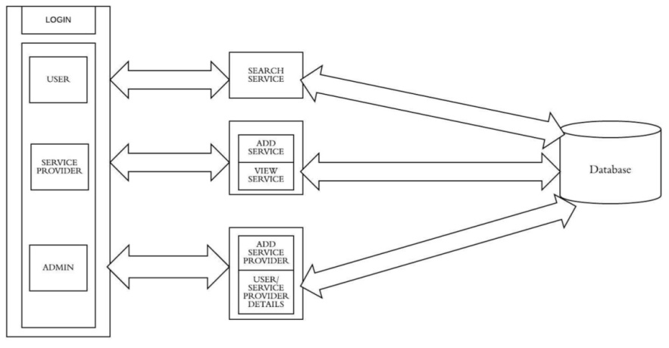

**Fig.1.Architecture for On Demand Home Service System**

**4.2 Login Module:**

The system consists of login for admin, user and service provider. To access the various functionalities, the registration process has to be completed first. Once the registration process is completed, the various features available in the system can be accessedare shown in flow diagram and login page in fig.2.There are two logins for user and service provider. once the user and service provider give the credentials and it is verified from the database. If they have already registered they can login into their account. When the user login, he can search the services by using search services option. Once search services option is selected the information regarding the services is retrieved from the database. The services are displayed to the users.

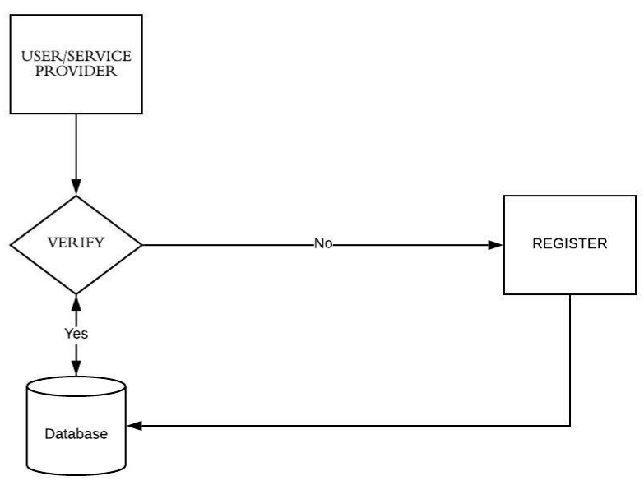

**Fig.2.Architecture for Login Module**

**4.3 SERVICES MODULE**

When customers want to plan a service, they will do it by logging in to their account. The system features a specialized with an interactive interface which offers smart way of holding a service, where users demand to supply the specifics about the services required. If required, customers clarify their doubts of particulars through chat bot. When service made, the request is submitted and it is directed to payments to be done as shown in fig3.

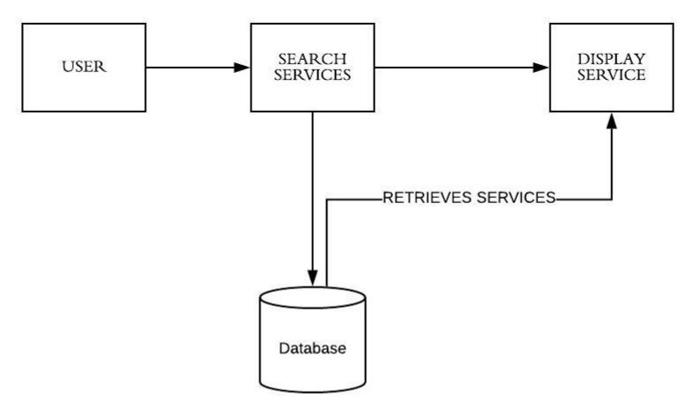

**Fig.3.Architecture for Services Module**

**4.4 ADMIN MODULE**

The admin module consists of the details about the users, services available and the service providers. Admin have the right to modify or add or delete the particular services or service providers once they violate principles. They map the user with the provider based on the request by the customer. Admin act as intermediate between the providers and users by sending the status of the requested service shown in fig.4. This helps the users to urge instant updates.

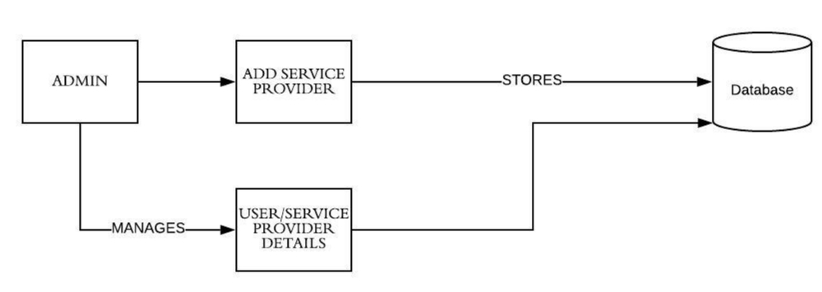

**Fig.4.Architecture for Admin module**

Admin can add the service provider’s details and the details of services will be stored in the database. Admin also manages the user details and details of user will be stored in the database.

**CHAPTER 5**

**RESULTS**

The proposed system helps the users to trace the status of the service they demanded. The tracking functionality in this system makes the user to verify whether the service request has been processed or notthe information about the service provider is given which can be viewed by both admin and the users. This helps the users as well as the admin to know the available providers for requesting the service and make the admin to get connect the proper provider to customers. The details of the services are stored within the database and it can be viewed by the admin as they act as an intermediate between the service provider and the customer. The availability of these details helps the admin to know the appropriate type of services for the service requested by the customers.

**CHAPTER 6**

**CONCLUSION AND FUTURE SCOPE**

To reduce the burden in finding apt service providers this application provides the detailed information which helps the users to get their services fulfil instantly. Unlike the other application, the application consists of the chat bot which helps the users to clarify the queries posted. Thus, this application appears to be livelier than the prevailing system. The on demand home service application provides some of the home services which are most frequently used. This system accommodates the changing needs of the end user. The overall system can be designed so that its capacity can be increased in response to the further requirements for which the application provides an appropriate service overseas. Further this application can be prolonged by merely adding up the required services For example, the current system provides the following services such as electronic repair, plumber repair and service further the system can be extended as per the requirements of the user.

**APPENDICES I**

**SCREENSHOTS**

**Login Page for On Demand Home Service System**

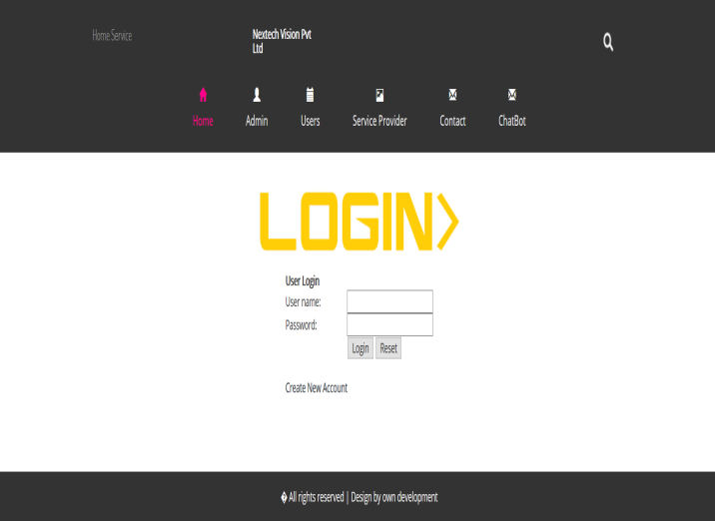

The above screenshot is the login page where the appropriate credentials like user name, password has to be given in order to access the services provided by the system. If the user forgot the password, then they can reset the password using reset option. If the user does not have the account then they can create the account using create account option.

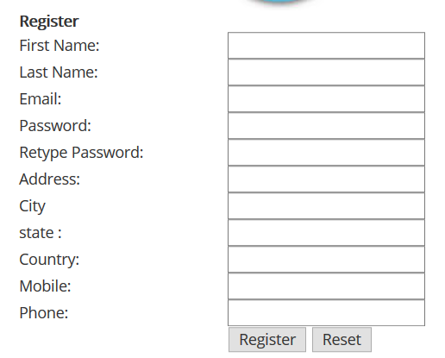

Once the create account is chosen, the details like first name, last name, email, password, address, city, state, country, mobile number has to be given to create the account.

**Admin Page for On Demand Home Service System**

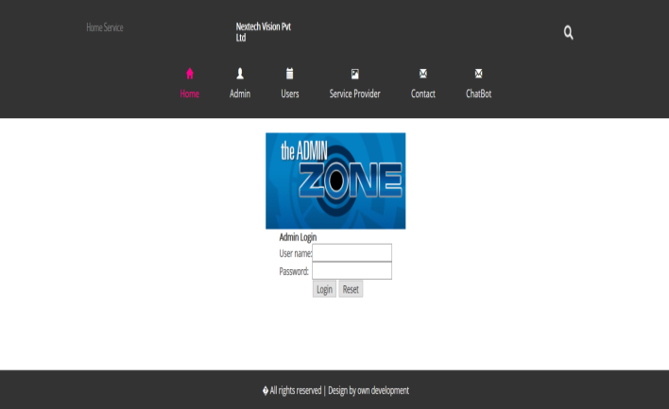

The above screenshot is the admin page where the admin can login using the credentials. Once the admin login he can add the service providers, services, user registrations details and viewing of feedback. The admin has the right of adding the services along with the details and the category under which the services come.

**Service Provider Page for On Demand Home Service System**

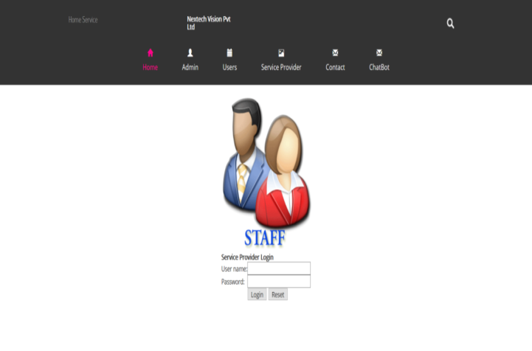

Once the service provider login through their credentials, they can able to view the applied services, add rules that has to be satisfied for the services to be provided. The services that are requested can also be viewed by the providers. The registered user details are also visible to the providers.

**Service Provider Page for On Demand Home Service System**

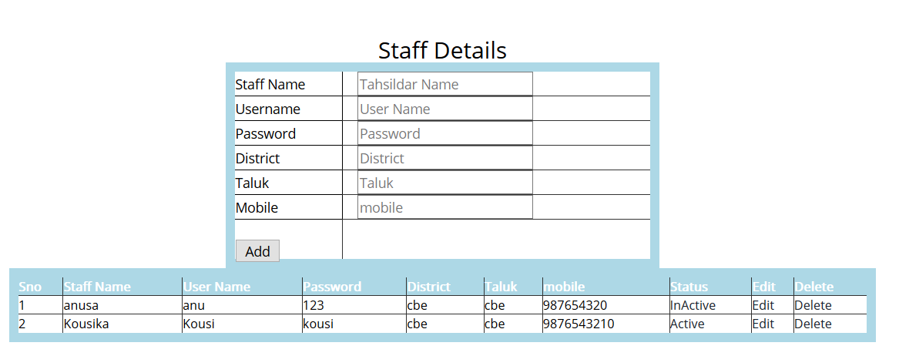

The above screenshot depicts the service provider details along with the contact number and their location.The status of the service provider can also be viewed by the admin so that they can ensure before the services to be confirmed.

**Service Details Page for On Demand Home Service System**

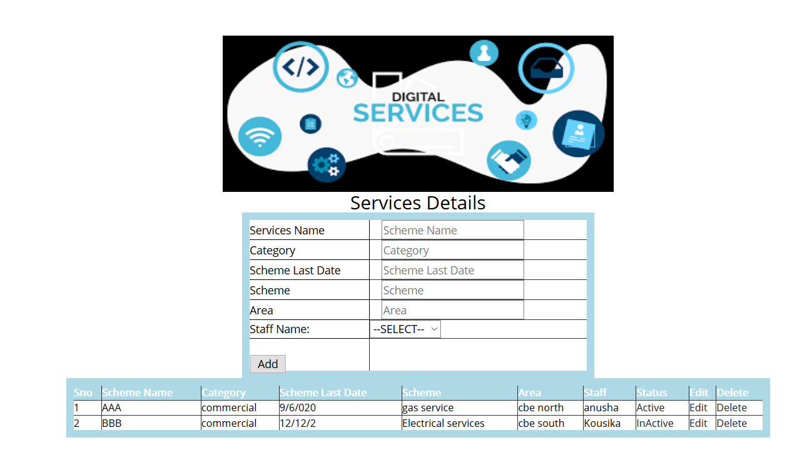

The above screenshot displays the services that are provided by various providers along with the information like the location, provider details. This helps in viewing the required services based on the requirement of the user who are in need of the services.

**APPENDICES II**

**SOURCE CODE**

**LOGIN CODE:**

<?php

include_once("config/config.php");

if(isset($_POST['login'])){

if($_POST['email_id']=="admin" && $_POST['password']=="admin")

{

echo '<script> alert("Login success"); window.location.href = "adminhome.php" </script>';

}

{

echo '<script> alert("Login Failed");</script>';

}

}

include("header.php");

?>

<script type="text/javascript">

$(document).ready(function(){

$("#login_form").validate();

});

</script>

<div align="center">

<form action="" name="login_form" id="login_form" method="post">

<br />

<imgsrc="logo.png"></img>

<table border="0" class="displaycontent" >

<tr>

<thcolspan="2">Admin Login</th>

<tr>

<tr>

<td class="col">User name:</td>

<td><input type="text" name="email_id" value="" class="required email"/></td>

</tr>

<tr>

<td class="col">Password:</td>

<td><input type="password" name="password" value="" class="required"/></td>

</tr>

<tr>

<td>&nbsp;</td>

<td>

<input type="submit" name="login" value="Login" />

<input type="Reset" value="Reset" />

</td>

</tr>

<tr><td colspan="2">&nbsp;</td></tr>

<tr>

</tr>

</table>

</form>

</div>

</div>

<?php include("footer.php")?>

**ADMIN CODE:**

<!DOCTYPE html PUBLIC "-//W3C//DTD XHTML 1.0 Transitional//EN" "http://www.w3.org/TR/xhtml1/DTD/xhtml1-transitional.dtd">

<html>

<head>

<title>On Demand Home Service</title>

<link href="css/bootstrap.css" rel='stylesheet' type='text/css' />

<!--jQuery (Bootstrap's JavaScript plugins) -->

<scriptsrc="js/jquery.min.js"></script>

<!-- Custom Theme files -->

<link href="css/style.css" rel="stylesheet" type="text/css" media="all" />

<!-- Custom Theme files -->

<meta name="viewport" content="width=device-width, initial-scale=1">

<meta http-equiv="Content-Type" content="text/html; charset=utf-8" />

<meta name="keywords" content="Charity Responsive web template, Bootstrap Web Templates, Flat Web Templates, Android Compatible web template,

Smartphone Compatible web template, free webdesigns for Nokia, Samsung, LG, SonyErricsson, Motorola web design" />

<script type="application/x-javascript">addEventListener("load", function() { setTimeout(hideURLbar, 0); }, false); function hideURLbar(){ window.scrollTo(0,1); } </script>

</head>

<body>

<!---->

<div class="header">

<div class="container">

<div class="header-top">

<div class="logo">

<a href="index.html"><h1><span> On Demand Home Service</span></h1></a>

</div>

<div class="hdr-address">

<div class="call">

<h5>On Demand Home Service</h5>

</div>

<div class="clearfix"></div>

</div>

<div class="search">

<div class="search-box">

<div id="sb-search" class="sb-search">

<form>

<input class="sb-search-input" placeholder="search term..." type="search" name="search" id="search">

<input class="sb-search-submit" type="submit" value="">

<span class="sb-icon-search"></span>

</form>

</div>

</div>

</div>

<div class="clearfix"></div>

<!-- search-scripts -->

<scriptsrc="js/classie.js"></script>

<scriptsrc="js/uisearch.js"></script>

<script>

newUISearch(document.getElementById( 'sb-search' ) );

</script>

<!-- //search-scripts -->

</div>

<div class="top-menu">

<span class="menu">MENU</span>

<ul>

<li class="active"><a href="adminhome.php"><span class="glyphiconglyphicon-home" aria-hidden="true"></span>Home</a></li>

<li><ahref="addstaff.php"><span class="glyphiconglyphicon-user" aria-hidden="true"></span>Add Staffs</a></li>

<li><ahref="addevent.php"><span class="glyphiconglyphicon-calendar" aria-hidden="true"></span>Add Services</a></li>

<li><ahref="viewreg.php"><span class="glyphiconglyphicon-picture" aria-hidden="true"></span>Users Registeration Details</a></li>

<li><ahref="index.php"><span class="glyphiconglyphicon-envelope" aria-hidden="true"></span>Log Out</a></li>

</ul>

</div>

<!-- script-for-menu -->

<script>

$("span.menu").click(function(){

$(".top-menu ul").slideToggle("slow" , function(){

});

});

</script>

<!-- script-for-menu -->

<div class="clearfix"></div>

</div>

</div>

**SERVICES CODE:**

<?php

include_once("config.php");

include_once("staffheader.php");

error_reporting(0);

mysql_connect("localhost","root","") or die(mysql_error());

mysql_select_db("event") or die(mysql_error());

$query = "select * from event";

$result = mysql_query($query) or die(mysql_error());

?>

<div align="center">

<br>

<br>

<br>

<br>

<br>

<br>

<h2> Scheme Details </h2>

<center>

<table border="1" cellspacing="6" class="displaycontent" width="800" style="border:10px solid Green;" align="center">

<tr>

<td bgcolor=Yellow><strong><font color="Red">Scheme Name</font></strong></td>

<td bgcolor=Yellow><strong><font color="Red">Category</font></strong></td>

<td bgcolor=Yellow><strong><font color="Red">Last date</font></strong></td>

<td bgcolor=Yellow><strong><font color="Red">Schemes</font></strong></td>

<td bgcolor=Yellow><strong><font color="Red">Area</font></strong></td

bgcolor=Yellow><strong><font color="Red">Tahsildar</font></strong></td>

</tr>

<?php

while($row=mysql_fetch_array($result))

{

?>

<tr>

<td style="color: #000000"><?php echo $row['name']; ?></td>

<td style="color: #000000"><?php echo $row['category']; ?></td>

<td style="color: #000000"><?php echo $row['edate']; ?></td>

<td style="color: #000000"><?php echo $row['eventtime']; ?></td>

<td style="color: #000000"><?php echo $row['venue']; ?></td>

<td style="color: #000000"><?php echo $row['staff']; ?></td>

</tr>

<?php

}

?>

</table>

<form action="viewevents.php" name="Viewuser" class="row" method="post">

<?php

if(isset($_GET['send']))

{

$query1 = "update tab_user set status='yes' where U_name='".$_GET['send']."'";

echo $query1;

if(mysql_query($query1))

{

echo '<script> alert("Accepted ok");</script>';

}

// echo '<script>alert("Notok");</script>';

header("location:viewuser.php");

exit;

}

if(isset($_GET['rej']))

{

$query1 = "update tab_user set status='no' whereU_name='".$_GET['rej']."'";

//echo $query1;

if(mysql_query($query1))

{

echo '<script> alert("Rejected ok");</script>';

}

// echo '<script>alert("Notok");</script>';

header("location:viewuser.php");

exit;

} ?>

<br>

<br>

<br>

<br>

<br>

<br>

<br>

<br>

<br>

<br>

</form>

</div>

<?phpinclude_once("footer.php")?>

</div> <!-- End row -->

</div>

</div>

**ADD SERVICES:**

<?php

include_once("config.php");

$query = "select * from event";

$result = mysql_query($query) or die(mysql_error());

while($row = mysql_fetch_assoc($result))

{

$cname[] = $row;

}

if(isset($_GET['edit']))

{

$id = $_GET['edit'];

}

else

{

$id = '';

}

$i=1;

include_once("adminheader.php");

?>

<?php

mysql_connect("localhost","root","") or die(mysql_error());

mysql_select_db("event") or die(mysql_error());

if(isset($_POST['up_name']))

{

$query = "UPDATE `event` set name='".$_POST['up_name']."',category='".$_POST['up_category']."',edate='".$_POST['up_edate']."',eventtime='".$_POST['up_eventtime']."',venue='".$_POST['up_venue']."',staff='".$_POST['up_staff']."' where id=".$_GET['edit']."";

echo $query;

if(mysql_query($query))

{

$_SESSION['message']='<span class="succuess">Record updated succussfully</span>';

header('location:addevent.php');

}

else

{

$_SESSION['message']='<span class="fail">Record Not Updated</span>';

}

header("location:addevent.php");

exit;

}

if(isset($_GET['stat']))

{

// echo '<script>alert("hi");</script>';

//echo 'hhhhhi';

$query = "UPDATE `event` set status=if(status='Active','InActive','Active') where id=".$_GET['stat']."";

echo $query;

if(mysql_query($query))

{

$_SESSION['message']='<span class="succuess">Record updated succussfully</span>';

header('location:addevent.php');

}

else

{

$_SESSION['message']='<span class="fail">Record Not Updated</span>';

}

header("location:addevent.php");

exit;

}

if(isset($_POST['submit']))

{

$query = "insert into `event` values (null,'".$_POST['name']."','".$_POST['category']."','".$_POST['edate']."','".$_POST['eventtime']."','".$_POST['venue']."','".$_POST['staff']."','Active')";

echo $query;

if(mysql_query($query))

{

$_SESSION['message']='<span class="succuess">Record Inserted succussfully</span>';

header('location:addevent.php');

}

else

{

$_SESSION['message']='<span class="fail">Record Not Updated</span>';

}

header("location:addevent.php");

exit;

}

?>

<?php

mysql_connect("localhost","root","") or die(mysql_error());

mysql_select_db("event") or die(mysql_error());

if(isset($_GET['delete']))

{

$query = "delete from event where id=".$_GET['delete']."";

mysql_query($query);

echo '<script>alert("Deleted");</script>';

$_SESSION['message']='<span class="succuess">Record Delete succussfully</span>';

header("location:addevent.php");

exit;

}

?>

<style>

table.tabtrtd,table.tabtrth{

padding:5px;

border:1px solid #000;

}

</style>

</br>

</br>

</br>

</br>

<form action="" name="edateform" method="post" enctype="multipart/form-data">

<div align="center">

</br>

<imgsrc="service.png" width="500" height="200">

<h3 align="center" style="color: #000000" >Services Details</h3>

<table width="450" border="2" cellpadding="2" cellspacing="2" class="displaycontent" style="border:10px solid lightblue;" align="center" >

<tr>

<td style="color: #000000"> Services Name </td>

<td>

<div id="eventtime" class="col-md-12">

<input type="text" name="name" placeholder="Scheme Name" style="color: #000000"></div></td></tr>

<tr>

<tr>

<td style="color: #000000"> Category</td>

<td>

<div id="eventtime" class="col-md-12">

<input type="text" name="category" placeholder="Category" style="color: #000000"></div></td></tr>

<tr>

<tr>

<td style="color: #000000"> Scheme Last Date</td>

<td>

<div id="eventtime" class="col-md-12">

<input type="text" name="edate" placeholder="Scheme Last Date" style="color: #000000"></div></td>

</tr>

<tr>

<tr>

<td style="color: #000000">Scheme </td>

<td>

<div id="eventtime" class="col-md-12">

<input type="text" name="eventtime" placeholder="Scheme" style="color: #000000"></div></td></tr>

<tr>

<tr>

<td style="color: #000000"> Area</td>

<td>

<div id="eventtime" class="col-md-12">

<input type="text" name="venue" placeholder="Area" style="color: #000000"></div></td></tr>

<tr>

<td class="col" style="color: #000000">Staff Name:</td>

<td>

<select name="staff" style="color: #000000" onchange="getUserInfo(this.value)" >

<!--<select name="goods_id" > -->

<option><strong>--SELECT--</strong></option>

<?php $a = array() ;

$a['U_name'] = '';

$goods_query=mysql_query("select * from staff") or die(mysql_error());

while($fetch_goods_id=mysql_fetch_array($goods_query))

{

echo '<option value="'.$fetch_goods_id['name'].'">';;

echo $fetch_goods_id['name'].'<br/>';

echo ' </option>';

if(isset($_POST['name']) && $_POST['name']==$fetch_goods_id['name']){

$a = $fetch_goods_id;

}

}

?>

</select>

</td>

</tr>

<tr>

<td>

</br>

<input type="submit" name="submit" value="Add" id="submit" style="color: #000000" />

</td><tr>

<div align="center">

<center>

<table width="900" border="2" cellpadding="2" cellspacing="2" class="displaycontent" style="border:10px solid lightblue;" align="center" >

<tr>

<thbgcolor=lightblue><font color=white size=2>Sno</font></th>

<thbgcolor=lightblue><font color=white size=2>Scheme Name</font></th>

<thbgcolor=lightblue><font color=white size=2>Category</font></td>

<thbgcolor=lightblue><font color=white size=2>Scheme Last Date</font></td>

<thbgcolor=lightblue><font color=white size=2>Scheme</font></td>

<thbgcolor=lightblue><font color=white size=2>Area</font></td>

<thbgcolor=lightblue><font color=white size=2>Staff</font></td>

<thbgcolor=lightblue><font color=white size=2>Status</font></td>

<thbgcolor=lightblue><font color=white size=2>Edit</font></th>

<thbgcolor=lightblue><font color=white size=2>Delete</font></th>

</tr>

<?php

if(count($cname)>0){

foreach($cname as $cat){

if($id == $cat['id']){

?>

<tr>

<td><?php echo $i++; ?></td>

<td><font color=#000000 size=2><input type="text" value="<?php echo $cat['name'];?>" name="up_name" class="required" /></font></td>

<td><font color=#000000 size=2><input type="text" value="<?php echo $cat['category'];?>" name="up_category" class="required" /></font></td>

<td><font color=#000000 size=2><input type="text" value="<?php echo $cat['edate'];?>" name="up_edate" class="required" /></font></td>

<td><font color=#000000 size=2><input type="text" value="<?php echo $cat['eventtime'];?>" name="up_eventtime" class="required" /></font></td>

<td><font color=#000000 size=2><input type="text" value="<?php echo $cat['venue'];?>" name="up_venue" class="required" /></font></td>

<td><font color=#000000 size=2><input type="text" value="<?php echo $cat['staff'];?>" name="up_staff" class="required" /></font></td>

<td bgcolor=white><font color=#000000 size=2><a href="?stat=<?php echo $cat['id'];?>"><?php echo $cat['status']; ?></a></font></td>

<td><font color=#000000 size=2><input type="hidden" value="<?php echo $id; ?>" name="id"/>

<input type="submit" value="update" /></font></td>

<td><font color=#000000 size=2><input type="button" value="cancel" onClick="window.location.href='addevent.php';"/></font></td>

<td><input type="submit" value="delete" name="delete"/></td>

</tr>

<?php }

else

{

?>

<tr>

<td bgcolor=white><font color=#000000 size=2><?php echo $i++; ?></font></td>

<td bgcolor=white><font color=#000000 size=2><?php echo $cat['name']; ?></font></td>

<td bgcolor=white><font color=#000000 size=2><?php echo $cat['category']; ?></font></td>

<td bgcolor=white><font color=#000000 size=2><?php echo $cat['edate']; ?></font></td>

<td bgcolor=white><font color=#000000 size=2><?php echo $cat['eventtime']; ?></font></td>

<td bgcolor=white><font color=#000000 size=2><?php echo $cat['venue']; ?></font></td>

<td bgcolor=white><font color=#000000 size=2><?php echo $cat['staff']; ?></font></td>

<td bgcolor=white><font color=#000000 size=2><a href="?stat=<?php echo $cat['id'];?>">

<?php echo $cat['status']; ?></a></font></td>

<td bgcolor=white><font color=#000000 size=2>

<a href="?edit=<?php echo $cat['id'];?>">Edit</a></font></td>

<td bgcolor=white><font color=#000000 size=2><a href="?delete=<?php echo $cat['id'];?>">Delete</a></font></td>

</tr>

<?php

}

}

}

?>

</table>

</div>

<!-- End container -->

</form>

</br>

</br>

</br>

<?php

include_once("footer.php");

?>

**ADD RULE:**

<?php

include_once("config.php");

$query = "select * from tbl_rule";

$result = mysql_query($query) or die(mysql_error());

while($row = mysql_fetch_assoc($result))

{

$cname[] = $row;

}

if(isset($_GET['edit']))

{

$id = $_GET['edit'];

}

else

{

$id = '';

}

$i=1;

include_once("staffheader.php");

?>

<?php

mysql_connect("localhost","root","") or die(mysql_error());

mysql_select_db("event") or die(mysql_error());

if(isset($_POST['up_ruleid']))

{

$query = "UPDATE `tbl_rule` set ruleid='".$_POST['up_ruleid']."',rule='".$_POST['up_rule']."',event='".$_POST['up_event']."' where id=".$_GET['edit']."";

echo $query;

if(mysql_query($query))

{

$_SESSION['message']='<span class="succuess">Record updated succussfully</span>';

header('location:addrule.php');

}

else

{

$_SESSION['message']='<span class="fail">Record Not Updated</span>';

}

header("location:addrule.php");

exit;

}

if(isset($_POST['submit']))

{

$query = "insert into `tbl_rule` values (null,'".$_POST['ruleid']."','".$_POST['rule']."','".$_POST['event']."')";

echo $query;

if(mysql_query($query))

{

$_SESSION['message']='<span class="succuess">Record Inserted succussfully</span>';

header('location:addrule.php');

}

else

{

$_SESSION['message']='<span class="fail">Record Not Updated</span>';

}

header("location:addrule.php");

exit;

}

?>

<?php

mysql_connect("localhost","root","") or die(mysql_error());

mysql_select_db("event") or die(mysql_error());

if(isset($_GET['delete']))

{

$query = "delete from tbl_rule where id=".$_GET['delete']."";

mysql_query($query);

echo '<script>alert("Deleted");</script>';

$_SESSION['message']='<span class="succuess">Record Delete succussfully</span>';

header("location:addrule.php");

exit;

}

?>

<style>

table.tabtrtd,table.tabtrth{

padding:5px;

border:1px solid #000;

}

</style>

</br>

</br>

</br>

</br>

<form action="" name="edateform" method="post" enctype="multipart/form-data">

<div align="center">

</br>

<imgsrc="rules.jpeg" width="500" height="200">

<h3 align="center" style="color: #000000" >Scheme Rules Details</h3>

<table width="450" border="2" cellpadding="2" cellspacing="2" class="displaycontent" style="border:10px solid lightblue;" align="center" >

<tr>

<td style="color: #000000"> Rule ID</td>

<td>

<div id="eventtime" class="col-md-12">

<input type="text" name="ruleid" placeholder="Rules ID" style="color: #000000"></div></td></tr>

<tr>

<tr>

<td style="color: #000000"> Rules</td>

<td>

<div id="eventtime" class="col-md-12">

<input type="text" name="rule" placeholder="Rules" style="color: #000000"></div></td></tr>

<tr>

<td class="col" style="color: #000000">Scheme Name:</td>

<td>

<select name="event" style="color: #000000" onchange="getUserInfo(this.value)" >

<!--<select name="goods_id" > -->

<option><strong>--SELECT--</strong></option>

<?php $a = array() ;

$a['U_name'] = '';

$goods_query=mysql_query("select * from event") or die(mysql_error());

while($fetch_goods_id=mysql_fetch_array($goods_query))

{

echo '<option value="'.$fetch_goods_id['name'].'">';;

echo $fetch_goods_id['name'].'<br/>';

echo ' </option>';

if(isset($_POST['name']) && $_POST['name']==$fetch_goods_id['name']){

$a = $fetch_goods_id;

}

}

?>

</select>

</td>

</tr>

<tr>

<td>

</br>

<input type="submit" name="submit" value="Add" id="submit" style="color: #000000" />

</td>

<tr>

<div align="center">

<center>

<table width="900" border="2" cellpadding="2" cellspacing="2" class="displaycontent" style="border:10px solid lightblue;" align="center" >

<tr>

<thbgcolor=lightblue><font color=white size=2>Sno</font></th>

<thbgcolor=lightblue><font color=white size=2>Rule ID</font></th>

<thbgcolor=lightblue><font color=white size=2>Rules</font></td>

<thbgcolor=lightblue><font color=white size=2>Scheme Name</font></td>

<thbgcolor=lightblue><font color=white size=2>Edit</font></th>

<thbgcolor=lightblue><font color=white size=2>Delete</font></th>

</tr>

<?php

if(count($cname)>0){

foreach($cname as $cat){

if($id == $cat['id']){

?>

<tr>

<td>

<?php echo $i++; ?>

</td>

<td><font color=#000000 size=2><input type="text" value="<?php echo $cat['ruleid'];?>" name="up_ruleid" class="required" /></font></td>

<td><font color=#000000 size=2><input type="text" value="<?php echo $cat['rule'];?>" name="up_rule" class="required" /></font></td>

<td><font color=#000000 size=2><input type="text" value="<?php echo $cat['event'];?>" name="up_event" class="required" /></font></td>

<td><font color=#000000 size=2><input type="hidden" value="<?php echo $id; ?>" name="id"/>

<input type="submit" value="update" /></font></td>

<td><font color=#000000 size=2><input type="button" value="cancel" onClick="window.location.href='addrule.php';"/></font></td>

<td><input type="submit" value="delete" name="delete"/></td>

</tr>

<?php

}

else

{

?>

<tr>

<td bgcolor=white><font color=#000000 size=2><?php echo $i++; ?></font></td>

<tdbgcolor=white><font color=#000000 size=2><?php echo $cat['ruleid']; ?></font></td>

<td bgcolor=white><font color=#000000 size=2><?php echo $cat['rule']; ?></font></td> <td bgcolor=white><font color=#000000 size=2>

<?php echo $cat['event']; ?>

</font>

</td>

<td bgcolor=white><font color=#000000 size=2>

<a href="?edit=<?php echo $cat['id'];?>">Edit</a></font></td>

<td bgcolor=white><font color=#000000 size=2><a href="?delete=<?php

echo $cat['id'];?>">Delete</a></font></td>

</tr>

<?php

}

}

}

?>

</table>

</div>

<!-- End container -->

</form>

</br>

</br>

</br>

<?php

include_once("footer.php");

?>

**APPENDICES III**

**PUBLICATIONS**

**1. Scopus Indexed Journals:**

* T.S. Anusa, S. Kousika, A. Lakshmi Priya “Web Application Based On Demand Home Service System” in IEEE Xplore on 23 April 2020, DOI: 10.1109/ ICACCS 48705.2020.9074284.

<https://ieeexplore.ieee.org/document/9074344>

**2. International Conference:**

* T.S. Anusa, S. Kousika, .A. Lakshmi Priya “Web Application Based On Demand Home Service System” Proceeding of the 6th International Conference on Advancement Computing & Communication Systems - (ICACCS 2020) at Sri Eshwar College of Technology on 6-7 March 2020, Coimbatore, Tamil Nadu, India.

**REFERENCES**

1. Sheetal Bandekar, AvrilD’Silva, “Domestic Android Application for Home Services” International Journal of Computer Applications, ISSN No.0975 – 8887, Volume 148 – No.6, August 2016.
2. N. M. Indravasan, Adarsh G, Shruthi C, Shanthi K, “An Online System for Household Services” International Journal of Engineering Research & Technology (IJERT), ISSN: 2278-0181, May 2018.
3. Shahrzad Shahriari, Mohammadreza Shahriari, Saeidgheiji. “Ecommerce and It Impactson Global Trend And Market” International Journal of Research – Granthaalayah. Vol.3 (Iss.4): April 2015.
4. Bo Zhang, Ruihan Yong, Meizi Li, Jianguo Pan, Jifeng Huanglaa,“ A Hybrid Trust Evaluation Framework for E-commerce in Online Social Network: ” 2169-3536, IEEE. Translations and content mining are permitted for academic research, 2016.
5. ChenggangZhen, Peng Cheng. “Construction of campus trading platform based on third-party online payment” 2nd International Conference on Industrial and Information Systems, IEEE, 2010.
6. Sujit Kumar Basak, Irene Govender.“Examining the Impact of Privacy, Security, and Trust on the TAM and TTF Models for Ecommerce Consumers: A Pilot Study”, IEEE, 2009.
7. CAlYrnn-ping, WANG Yu-ying, “Simple Said about Online Payment Risks and Preventive Measure ”, China located International Conference on Information Systems for Crisis Response and Management, IEEE, 2010.
8. Dejan Kovachev and Ralf Klammadriano, “Beyond the Client Server Architectures: A Survey of Mobile Cloud Techniques”, workshop on mobile computing in 2011.
9. Teddy Mantoro, Admir Milišic, Media A. Ayu, “Online Payment Procedure Involving Mobile Phone Network Infrastructure and Devices”, IEEE, 2010.
10. Cong Yin, “An empirical study on users’ online payment behaviour of tourism website”, IEEE 12th International Conference on e-Business Engineering, 2015.